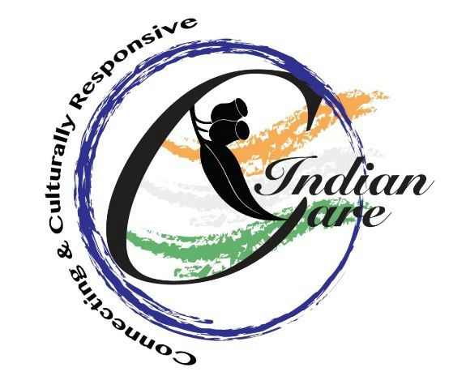
Minutes of IndianCare Incorporated Second Annual General Meeting, held on 22nd November 2015, 6 – 7pm
(reporting on the 2014 – 15 financial year)
Venue: Scoresby
Approximately 14 people in attendance. Apology – Geeta Devi
- Welcome and introduction by Anand Shome (Secretary, ICI)
- Previous AGM minutes were read by Durga Warrior. Moved by Jaya and passed by Asha.
- President’s Report - Jaya presented the year’s report of activities and thanked the following people and organisations - Elizabeth Drozd, AMCS; VMC and Rotary Club of Footscray for funding; and Victorian University for providing students. Jaya welcomed the guests and introduced ICI committee members and thanked each one of them for their continued support.
- Finance Report – Ramu Manchikanti read presented the financial report in the absence of Geeta Devi. A total income of $4528.10 was received for the financial year 2014-2015. There are no labilities and the account is in credit with $4528.10. The report was approved by the committee members. Moved by Jaya Manchikanti and seconded by Durga Warrior.

- Committee members for 2016 - 17 were elected unanimously.
President: Jaya Manchikanti
Vice President : Anand Shome
Secretary: Durga Warrior
Members: Geeta Devi, Ramu Manchikanti, Manjit Singh, Asha Padisetti

- Guest speaker - Elizabeth Drozd (CEO of AMCS)

- The AGM ended with a gift presented to Elizabeth for her continuing support to ICI, followed by beautiful singing by Mythilly and Naga Nagasundaram.

